INVERTEBRATES FOUND
NUMBER OF LEGS
ZERO | FOUR | SIX |  | EIGHT |  | LOTS
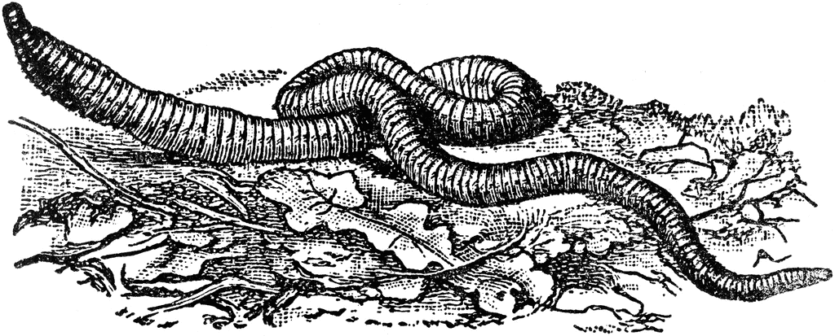 | NOT AN INVERTEBRATE  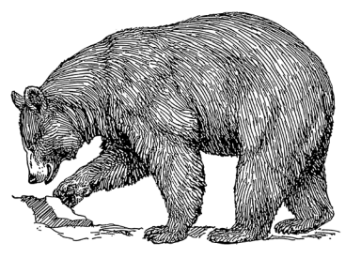 | 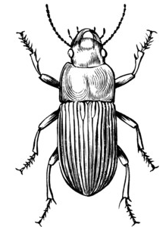 | 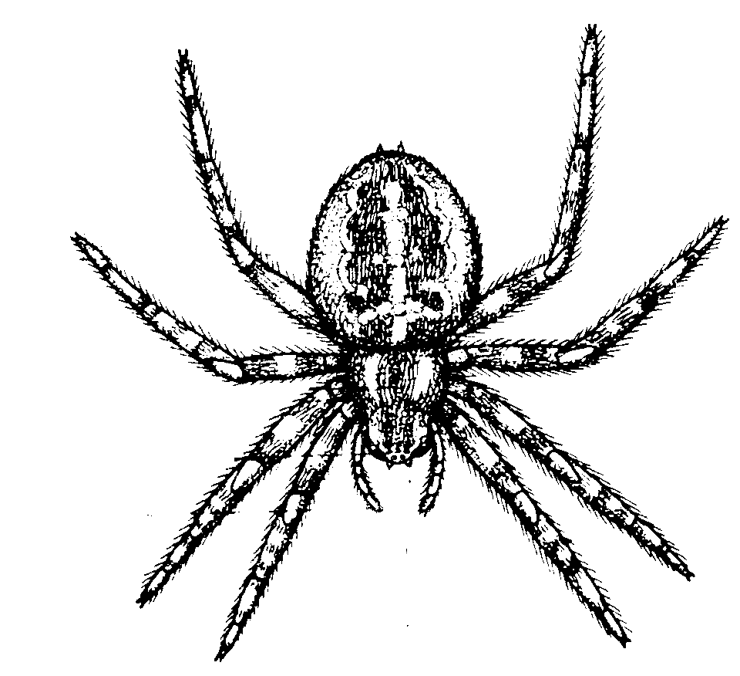 |  | 